Media and Creative Industries
Course Code: PSB5067PM
Student ID:M0296649W
Coursework 2: Portfolio Plan and Reflection

🌐 Web profile (showcasing your work)- https://zuoye.youdianzhuiqiu.cn/
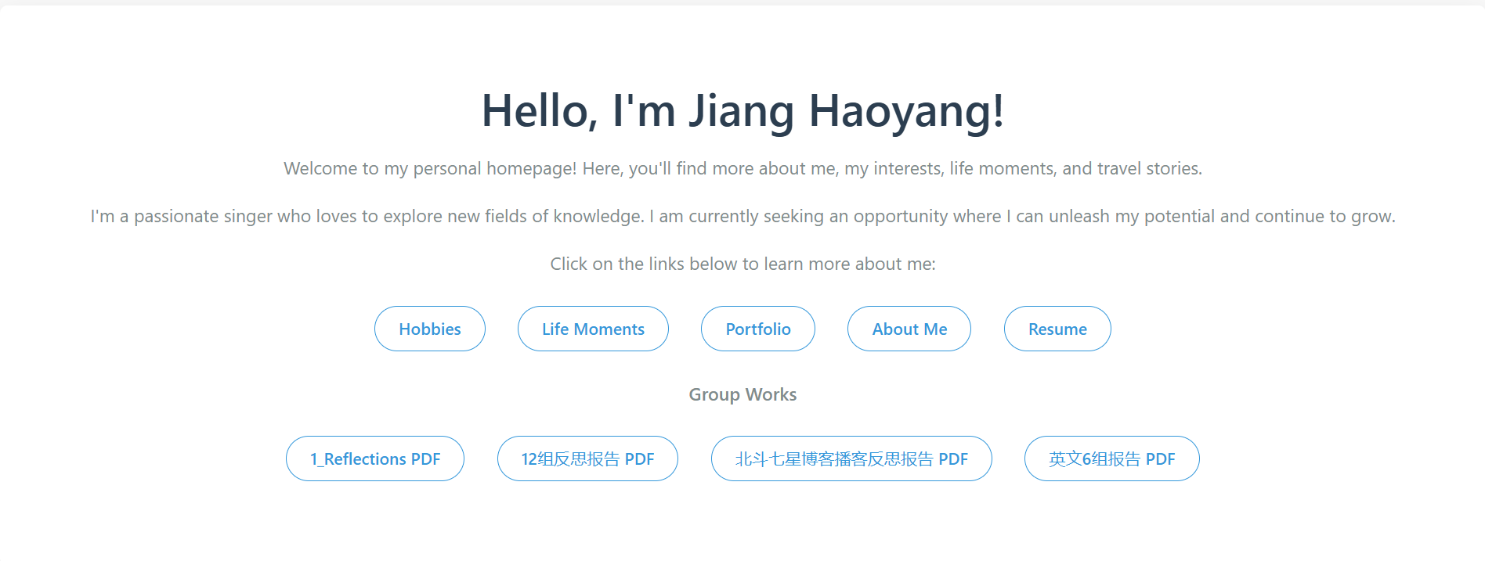
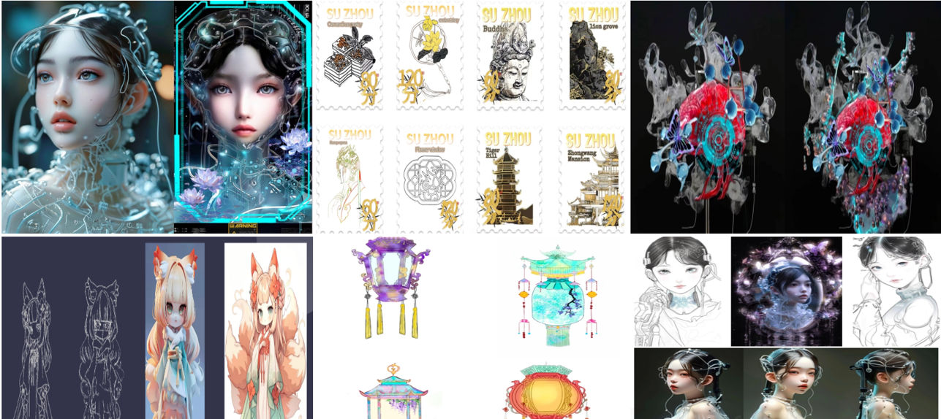
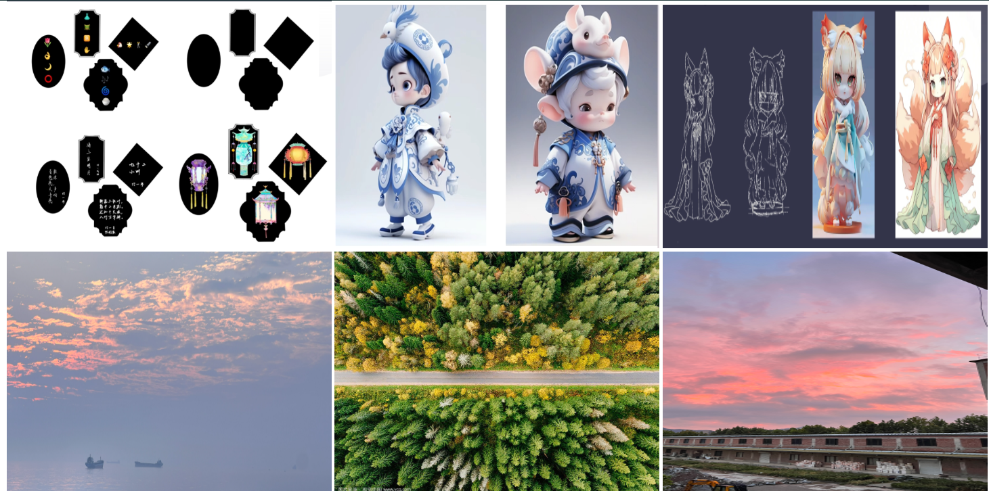
✍️ 500-word reflective statement
The three in-class career workshops helped me understand how to present myself effectively to the world when seeking employment. It gave me insights into how my resume should be structured, what to include, and how to present it effectively. Till now, I have had the basic idea and the purpose of a resume, job hunting and identity profiling. However, the workshops were an extensive idea of what makes a good resume and making one presentable for job. Specific ideas like not using first-person active voice and matching keywords with the targeted job description were a new thing to me. The idea of the Application Tracking System was also a new idea. I understood that this is a software program system that is used by companies to filter job applications. Hence, all the guidance, including the extraction of high-frequency words from 4-5 target JD positions, avoiding generic statements, using online tools like Jobscan or Career Potter platforms, among others, helped me gain knowledge about preparing my resume company-ready. I have integrated all these pointers into my resume that I have created for the portfolio.
The Coursework 1 was also a very professional experience for me. This project activity helped me to do an extensive study and research about my field. I got to understand the companies that dominate the advertising world, which put together are known as the ‘Big Six.’ Through this research, I was able to get an insight into the industry structure and hierarchies. This helped me filter down the companies that I am interested in. Through this, I was also able to know the key roles and responsibilities, and the key areas that I need to excel in. The research about companies presented an overview of what to add while matching keywords with the targeted job description, and mentioning my hard skills and soft skills in the resume. This is because I have had the chance to thoroughly understand the required qualifications and skills that professionals seek in an advertising role. Alongside that, as the emerging digital technologies have opened various scopes in the advertising industry, it is advantageous for me to learn and gain knowledge on a few of the basic technologies. It was delightful to know that there are multiple opportunities in this advertising industry, and I am walking on the right path.
For now, my career goal is to opt for a Marketing Assistant position in one of the top firms in Singapore. After evaluating my own skills and experiences, it would be too optimistic for me to apply for and go for an executive role. However, with my given qualifications and skills, the Marketing Assistant position will be perfect for me. As previously mentioned in my journal, compared to 2021, opportunities for internet advertising professionals will double by 2028 (PwC, 2024). Hence, based on my strengths, which are digital marketing, data analysis, ad campaign optimisation, social media management, and content creation, among others, there is a good growth opportunity for me in the internet advertising sector.

Reference
PwC. (2024). Perspectives: Global Entertainment & Media Outlook 2024–2028. PwC. https://www.pwc.com/gx/en/issues/business-model-reinvention/outlook/insights-and-perspectives.html

💼 Job ad
https://sg.linkedin.com/jobs/view/junior-entry-level-marketing-assistant-at-ignite-marketing-group-4239239588?utm_campaign=google_jobs_apply&utm_source=google_jobs_apply&utm_medium=organic
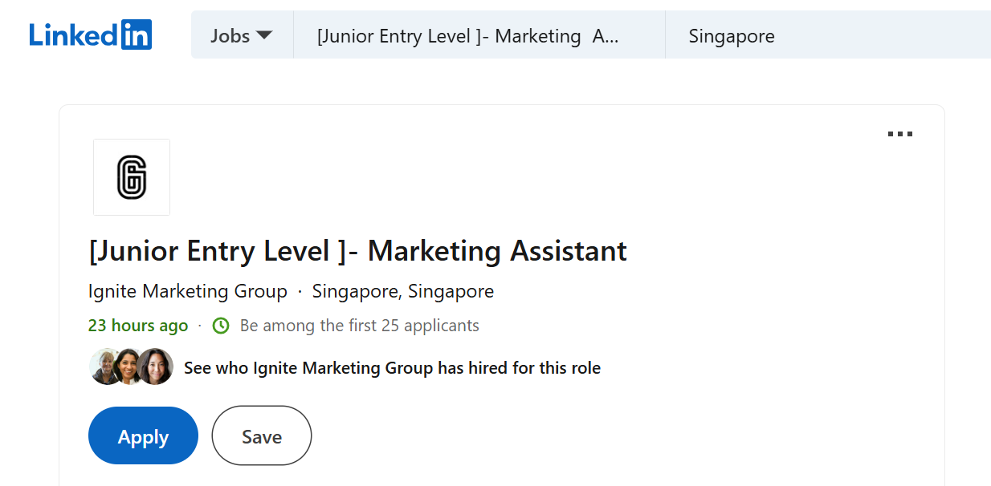
Requirements:
- Managing & Planning Events while training to build strong foundations of Sales & Marketing
- Hands-on Experience in Face-To-Face marketing and clients’ presentations
- Ongoing development through workshops & coaching, focusing on communication skills, public speaking and training new people
Job Scope:
- Mentorship provided- Training provided to guide thru your progression
- Travel opportunities- Expand your learning overseas regional & international
- A family-like & fun environment- Be in place where we celebrate every achievement together & grow together!
- Progression Opportunities - Performance based

🧾 Targeted CV/resume (PDF uploaded)
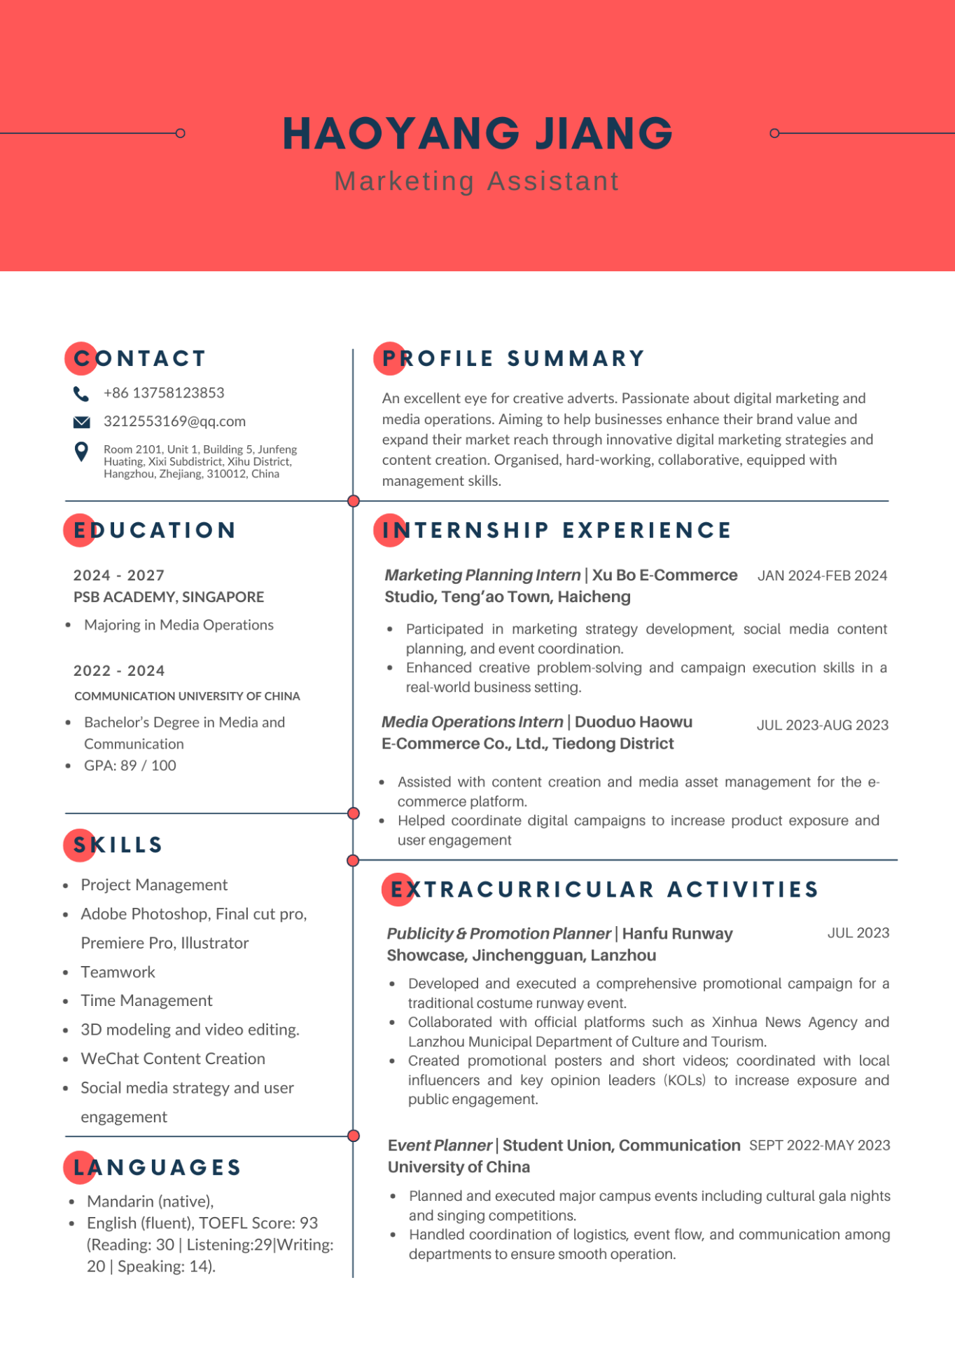

🧠 Skills audit + SWOT Analysis
Skills Audit
Job Requirement | My Abilities
- Managing & Planning Events while training to build strong foundations of Sales & Marketing  - Hands-on Experience in Face-To-Face marketing and clients’ presentations  - Ongoing development through workshops & coaching, focusing on communication skills, public speaking and training new people | - Worked as an Event Planner, so I have experience in management and planning.  - I have planned and executed team-building as part of my job, and I have also participated in team-building activities.  - Organised and planned community services, so have experience in facing clients.  - Similarly, have good communication skills as I was involved in work to increase volunteer participation and influence.

SWOT Analysis
Strengths:  - Proficiency in technical knowledge- Excel in design and creative tools like Adobe Photoshop, Illustrator, Premiere Pro, & Final Cut Pro. Experience in 3D modelling and video editing  - Knowledge of different media channels due to my internship as a Media Operations Intern at Duoduo Haowu E-Commerce Co., Ltd.  - Skilled in planning and management due to my internship as a Marketing Planning Intern, at Xu Bo E-Commerce Studio, Teng’ao Town. | Weaknesses:  - Even though there is experience in communication, there is still a lack of formal training regarding marketing principles.  - As a student, there is a very limited industry exposure, as till now, it has been few internships.  - Even though an expert in content creation, still lacks in analysing and strategising the market trends.  - Even though excel in designing tools, lack experience in marketing tools like CRM platforms, KPIs knowledge, Google Analytics and others.
Opportunities:  - Open to more internships and eager to apply for entry-level roles.  - As mentioned before about technological development, there is a huge opportunity for digital marketing growth.  - Gain more skills and collect more certificates in various marketing and management skills. | Threats:  - There is a high level of competition between candidates and employees  - Inventory of skills needed, like five skill categories (Di Gregorio et al., 2019).  - More analytical, soft, digital, technological, customer insight, and core marketing skills are needed.  - Pressure for constant innovation and self-promotion.

Reference:
Di Gregorio, A., Maggioni, I., Mauri, C., & Mazzucchelli, A. (2019). Employability Skills for Future Marketing Professionals. European Management Journal, 37(3), 251–258. https://doi.org/10.1016/j.emj.2019.03.004

🎓 Proof of webinars, events, training sessions
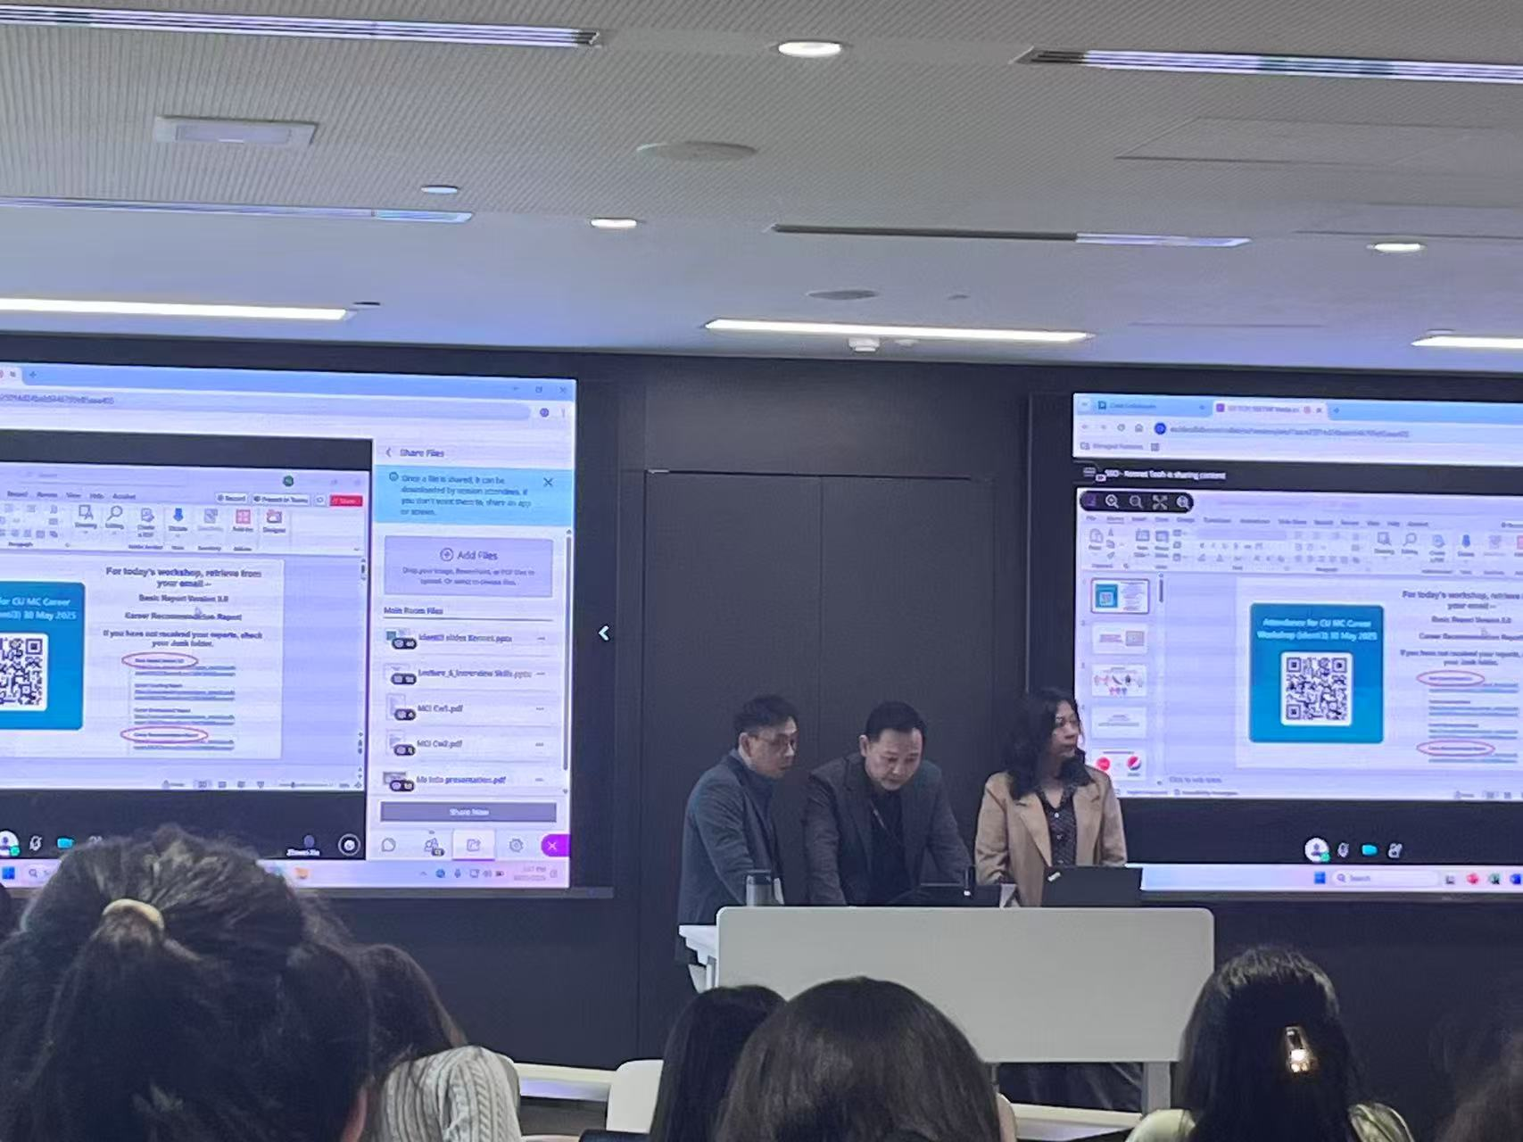
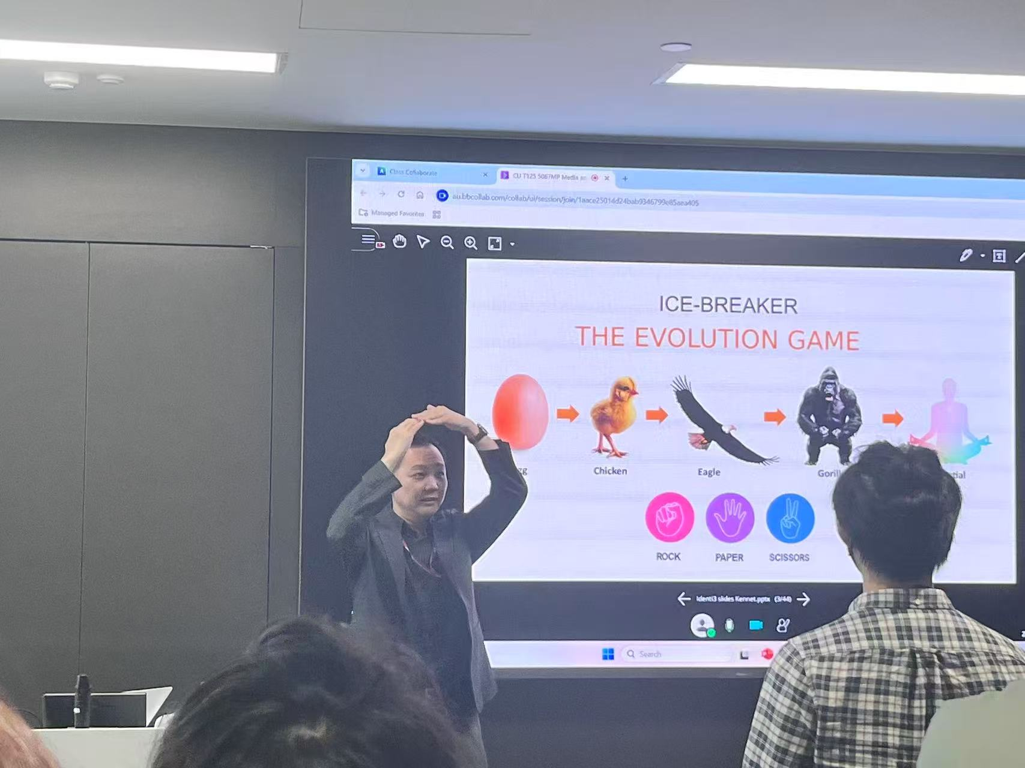
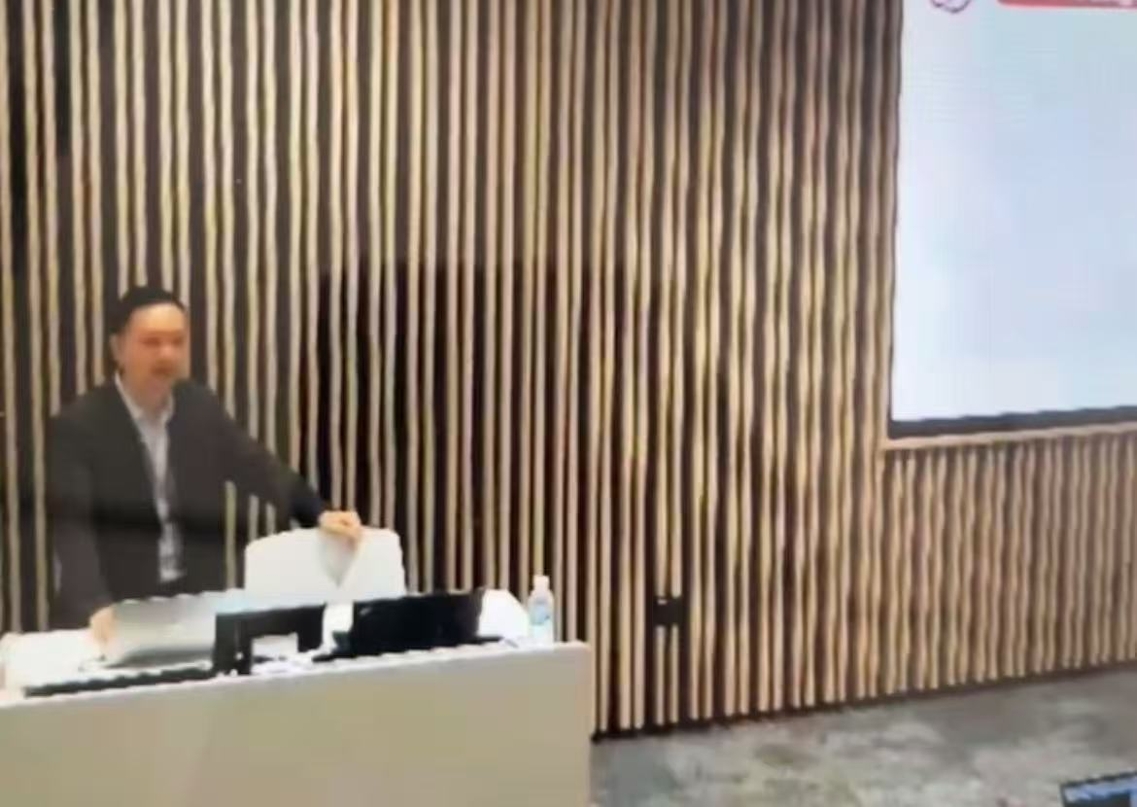

The webinars were quite effective for me as they acted as a practical overview of what we were learning. From the webinars, I learnt about various skills, especially the difference between technical skills and soft skills, challenges that can arise in a creative industry like competition, pressure for constant innovation and self-promotion, and especially the pathways that can lead me to my success. Secondly, the industry talks helped me to get insights into how the creative industry works. I learned the structure of how an advertising company works, alongside that, I also realised that basic qualifications like having a Bachelor’s degree are not enough for me to reach the top. I have to nurture myself, develop both technical and soft skills, as well as improve my practical marketing skills. Lastly, in my career events, I learned how to prepare my CV, cover letter, and attach keywords that match the company requirements in order to attract companies. I also learned about the Application Tracking System, which was also a new idea. Overall, it was a great learning experience for me. All these greatly mattered to me in my development, as all these learning experiences helped me prepare myself for the greater creative industry. Alongside that, it also helped me in making my portfolio and made me understand the industry in a better way. Lastly, all these mattered to me in my development as they helped me in growing and deciding my career goals and helped me understand the growing processes.

